What the app is and why it’s useful:
My Personal Finance Tracker allows users to track and manage their income and also their expenses. They are able to input transactions by whether it being an income or expense, and are able to assign it to a category. These categories being, food, rent, and entertainment. With their selection they are able to specify a certain amount of money. After making their selection and inputting their money, the app then updates their financial summary. This will show their income, and how much they spend all by category. It’s very useful because I believe many people are trying to save to their utmost ability due to increasing prices all around. This app will promote better budgeting and help people to stop overspending.

My Algorithms:

Add Transaction
- Get transitions type, category and amount from the user.
- Add it to the transaction history
- Push transaction to the undo stack
- Update the total for specified category,
  - If it’s income, add to the category’s total
  - If it’s expense, subtract from the category’s total
The Big O time being O(1).
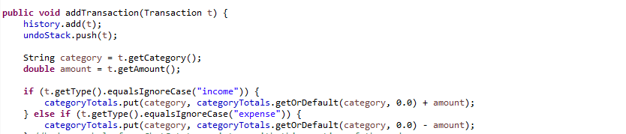
Undo Last Transaction
- Remove the last transaction off the undo stack
- Remove the transaction from the history
- Now reverse the effect it had on the category total
  - If it is an expense, add it to the total
  - If it is an income, subtract it to from the total
Big O time being O(1)
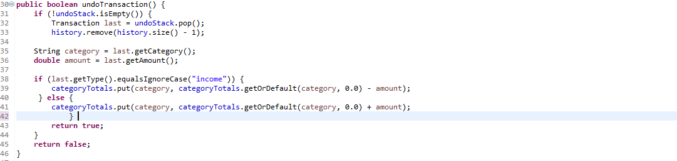
Print Financial Summary
- Loop through all categories, stored in the category totals (hashmap)
- Now print each category, and print its current total.
Big O time being O(n)
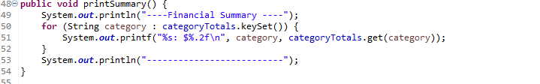

Algorithms explanation:

So as you can see above, my three algorithms are add transaction, undo transaction and print summary. My add transaction method will update the three data structures all at once, that being; the ArrayList history, the undo stack, and the hashmap for the category totals. These three will keep the history and summary accurate. Now the undo transaction is essentially the same. I will include that I used ChatGPT to help with the construct/outline of the code. But For this one I basically took the same concept from the add transaction but just reversed it. And then the Print summary just loops through the categories and prints your summary.

Data Structures:

The data structures I used are; ArrayList<Transaction> history, Stack<Transaction> undoStack, and HashMap<String, double> categoryTotals. I used an arrayList to maintain a record for all of the users entered transactions. I used a stack to help with the undoing portion of the transaction. And I used a hashmap to allow constant updates to the total of every category.

Development process:

One part that I didn’t really have planned was the undo option. When I first started the project I never really thought of implementing an undo option. There wasn’t really anything that happened to make me think of this, but I just thought it’d be a nice add. And it seemed super useful if used in the real world. People mess up, and if there wasn’t an undo option, they would have to restart.

Error:

The error that caused me the most trouble was figuring out how to get the undo feature to work. I had a lot of trouble on that one and couldn’t figure it out. That’s where I had to get the help from ChatGPT and it aided me to find my solution.

Additions for the future:

I think a very cool edition to have would be to add more categories. I think there could be a good amount of categories added that can relate to people's everyday lives.

